1. Major Assets for The Pet Park are either hash protected, or protected automatically by our API:
   1. User passwords: Hashed
   2. User posts: API
   3. User Comments: API
   4. User Profiles: API
2. Passwords for accounts on The Pet Park are hash encrypted which can be seen through the following SQL request:

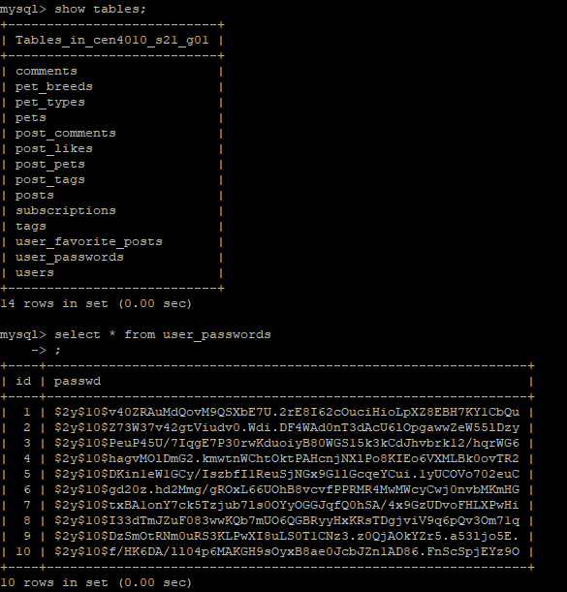

1. Confirm Input Data Validation:
   1. Create Post Validation:

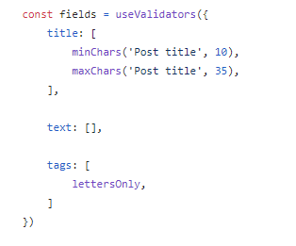

* 1. Signup Page Validation:

